

GUIDELINES FOR THE SAFE USE AND MOVEMENT OF

MILK TROLLEYS

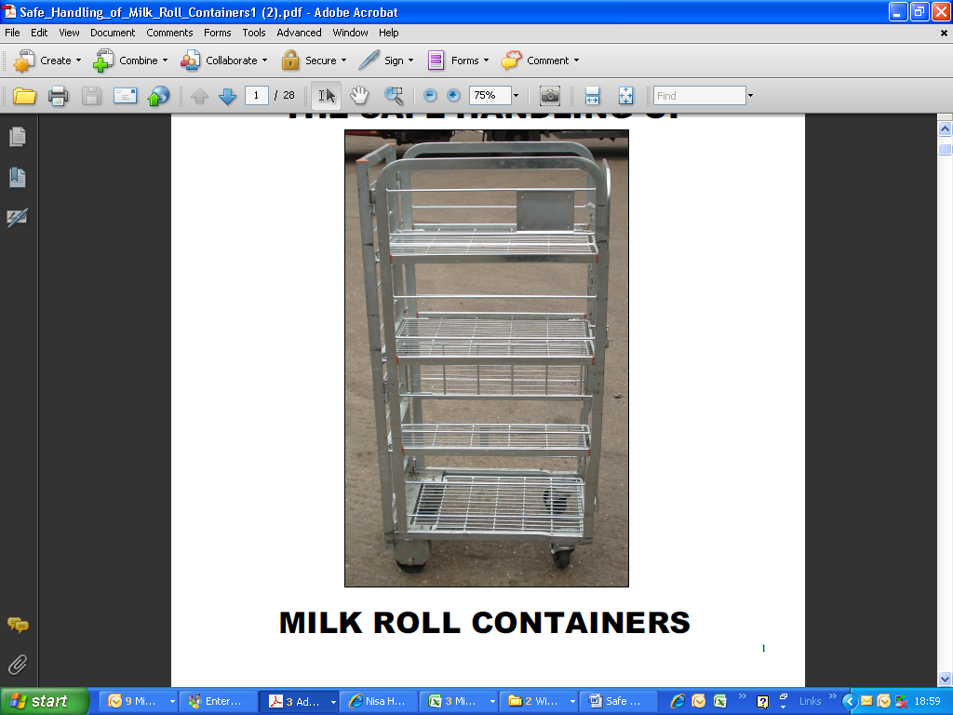

INDEX

|  |  |
| --- | --- |
| **ITEM** | **PAGE** |
| INTRODUCTION | 3 |
| MOVING TROLLEYS SAFELY | 4/5 |
| RISK ASSESSMENT: Environmental Issues – Poor Surface Examples | 6 |
| RISK ASSESSMENT: Maintenance – Checking Condition of Trolleys Before Movement | 7 |
| INFORMATION, INSTRUCTION AND TRAINING: Trolley Handling | 8-13 |
| APPENDIX 1: FORCES REQUIRED TO MOVE TROLLEY | 14 |
| APPENDIX 2: USEFUL WEBSITES AND FURTHER INFORMATION | 15 |
| APPENDIX 3: TROLLEY TEAM | 16 |

***This Guide has been prepared by Dairy UK’s Occupational Health & Safety Committee.***

***We gratefully acknowledge the following contributors:***

***Dairy UK, Dairy Crest Ltd, Ala Foods UK plc, Müller Wiseman Dairies, First Milk, Müller, Pristine Condition, Health and Safety Executive (HSE) and Health and Safety Laboratory (HSL).***

**INTRODUCTION**

**Aims**

This document has been produced by Dairy UK, in conjunction with its Occupational Health & Safety Committee, with the specific aims to promote best practice in the use of the industry’s milk trolley fleet, and to reduce the risk of Manual Handling injuries.

**The guidance covers**

* Ways to Avoid the need to manually handle trolleys by Elimination, Automation or mechanisation
* Identifying and minimising risks involved with all aspects of trolley movement,
* Outlining safe working practices for the handling of trolleys,
* Providing the framework to assist organisations in training their staff and others.

**What is a trolley**

***Description***

Milk Trolleys are small-wheeled metal distribution cages capable of transporting milk in non-returnable containers. They were introduced to allow easier and safer bulk delivery of milk to customers.

The trolley is normally fitted with a base and two or three shelves and can be hand packed or machine packed and nested for empty storage.

Each trolley is fitted with a hinged door, closed by a clip arrangement, and two fixed wheels at the rear and two swivel castors at the front (door) end.

***Dimensions and weights***

The overall dimensions of the four-tiered containers are 420mm wide, 660mm long and 1,300mm high and they hold the equivalent of 80 x 4 pints

Weights of trolleys vary between 30-35kgs empty and up to 217 kg full.

**What is the problem**

Although the trolleys make it easier for moving packaged milk, they are still involved in a significant number of the liquid milk sector’s accidents, e.g. in 2012/13 xx% of all manual handling injuries in a sample of the dairy sector, involving xxx employees (taken from those companies providing stats) were as a result of moving trolleys with xy% of those being off-site.

Typical causes of accident involve:

* Moving too many trolleys at the same time, whether empty or full,
* Pulling trolleys, particularly using an awkward twisted posture,
* Environmental conditions, including: uneven or rough floor surfaces such as checker plate, ramps, floor surface contamination, surface water, tail lifts,
* Condition of equipment, including: broken wheels, catches, latches, welds, sidebars, sharp edges, shelves and doors,
* Trolley tipping over (due to reasons above), and operators either trying to prevent them falling, or the trolley itself falls on the operator.

**MOVING TROLLEYS SAFELY**

The first principles of manual handling are to avoid the need to do it at all, through such things as automation *(see example photo of auto handling system on page 8)* or use of mechanical handling equipment *(see photos of MHE used to move both full and empty trolleys on page 8)*.

Where manually handling trolleys is necessary the risks to the handler need to be assessed to take into account the following:

* Capabilities of the handler
* The condition of the trolleys themselves (*refer to page 7*)
* Type and condition of floor surface and the distance the trolleys have to be moved *(refer to page 5)*
* Adequate lighting
* Length of shift and rest breaks

This assessment determines whether only one trolley must be moved at a time or it is permissible to allow a maximum of two trolleys to be moved. However moving two trolleys requires more effort and increases the risk of injury, therefore the only circumstances in which two trolleys can be moved at once is if the floor surface if flat, smooth, clean, dry and free from obstacles *(see photo example)*. These conditions usually exist within controlled cold stores and good practice is to only move one trolley when outside such controlled environments.

**HSE Guidance for pushing and pulling**

HSE guidance in appendix 3 of L23, the Manual Handling Regulations 1992 (as amended), provides filter figures for various kinds of handling.

If the forces required, or the loads handled, are above the appropriate filter figure, then a more detailed risk assessment should be carried out to find ways to further reduce the risk. If the forces of loads are below the appropriate filter figure, then the task is likely to be lower-risk and a more detailed assessment may not be required.

However even though the forces required may be low, ergonomic reports have indicated that the risk of injury when pulling or pushing two trolleys can still be medium or high, dependent upon the position the handler is in to move the trolleys, for example pulling two trolleys in an awkward twisted position *(see photo on page 9)*. Therefore a risk assessment should still be carried out based upon the task, individual capability, the load itself and the working environment.

The guideline figures for starting or stopping a load are:

* 20 kgf (about 200 N) for men
* 15 kgf (about 150 N) for women

Guideline figures for keeping a load in motion are half of these values.

In 2013 the Health and Safety Laboratory (HSL) carried out testing on the forces required to move one full trolley, two full trolleys and five empty trolleys, these being industry practice. The test results can be found in appendix 1.

***Good practice Guidelines for Moving trolleys safely***

Only move one full trolley at a time, for example inside trailers or on checker plate surface, at delivery sites, on ramps, outside surfaces, where distances of more than 20m are travelled or where many directional changes are required.

However, if the floor surface is well maintained, flat, smooth, without ridges, holes, slopes or loose surfaces, clean and dry (allowing easy trolley movement, with wheels aligned), and the handler is physically capable, a maximum of two trolleys can be moved, subject to risk assessment. Under no circumstances should more than two full trolleys ever be moved at the same time. Examples of bad floor surfaces and poorly maintained trolleys are shown on pages 6 and 7.

The recommended maximum number of empty trolleys to be moved is five. Always seek assistance from others if you cannot move the trolleys yourself.

In order to avoid any injury, those handling trolleys need to be given information about the handling risks, and both instruction and training in the correct handling techniques,

HSE guidance for manual handling looks for the elimination, or reduction, of a load handled as a priority, therefore the use of automation or mechanical handling equipment is always the first principle with examples provided in this document *(see page 8)*. Reducing the weight and forces required to move the load is the second principle, where reasonably practicable, so moving one trolley instead of two.

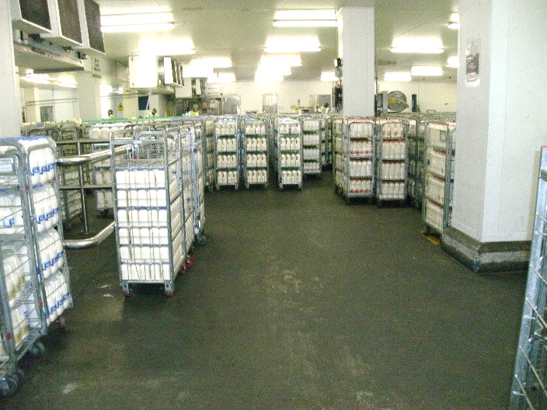

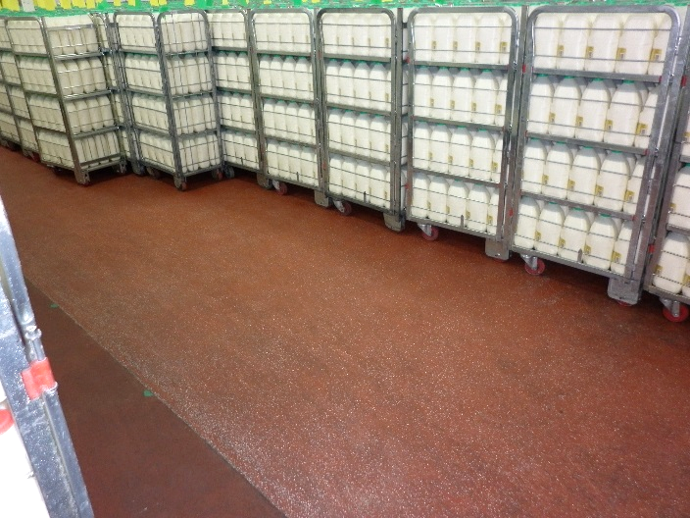

Examples of good floor surfaces on which a maximum

of two trolleys could be moved, subject to risk assessment

(do we need floor specification details?)

***Personal Protection Equipment (P.P.E)***

The correct use of protective clothing is essential when working with trolleys, i.e. gloves, safety footwear with ankle protection and ear protection (where required).

**RISK ASSESSMENT:**

***Environmental Issues – Poor Surface Examples***

**Poor floor surfaces can cause trolleys to become unstable and topple over.**

All poor floor surfaces should be reported immediately and appropriate action should be taken to remedy the situation. Such conditions would require only one trolley to be moved, if safe to do so.

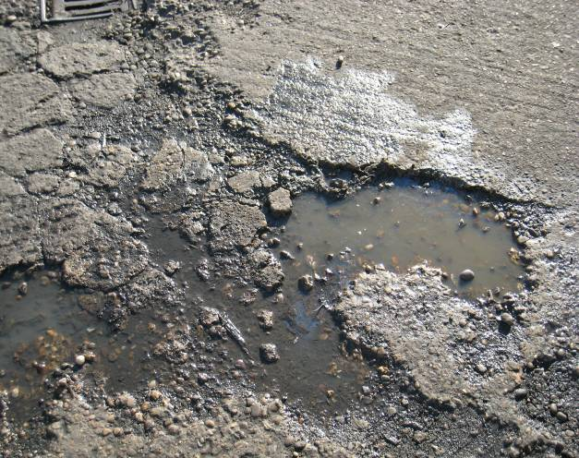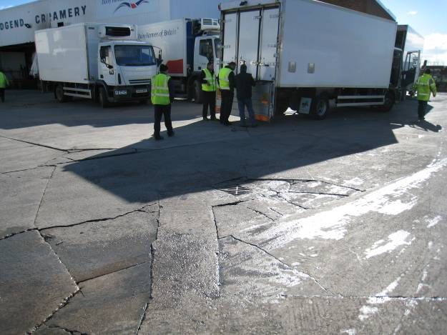

Pot holed surface

Uneven surface

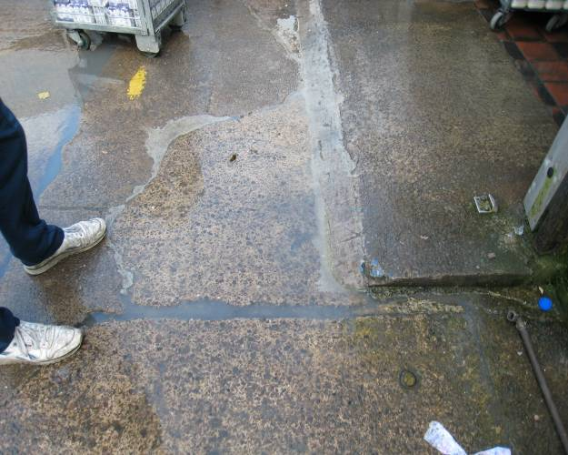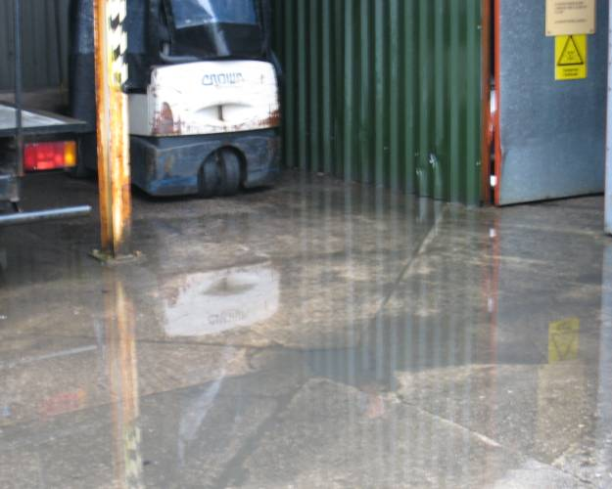

Small Lip

Surface water

**Insert photo of checker plate *(tbc)***

**Insert photo of a ramp *(tbc)***

**RISK ASSESSMENT:**

***Maintenance – Checking Condition of Trolleys Before Movement***

**Damaged trolleys should be removed from use.**

The trolley should be marked as unusable and repaired following your company procedure.

|  |  |  |
| --- | --- | --- |
| Shattered wheel | Broken wheel plate | Broken door |
| P5010002Broken bars | ш°Missing or damaged latch / catches | Wheel caught up in packing tape |
| ю°Door, frame, hinges bent or missing | ю°Wheels bent so trolley is unstable | Trolley photos Jan 2010 005An example of a red tag system to indicate a damaged trolley |

**INFORMATION, INSTRUCTION AND TRAINING:**

***Trolley Handling***

|  |  |  |  |
| --- | --- | --- | --- |
| **Procedure** | **Full trolleys** | **Full trolleys** | |
| ***Using automated systems to move trolleys***  Where possible, the first principle is always to use an automated system – usually for high volume trolley movement. |  | |  |
| **Procedure** | **Full trolleys** | **Empty trolleys** | |
| ***Using equipment to move trolleys***  Where possible, the first principle is always to move trolleys using mechanical handling equipment. |  | | **C:\Documents and Settings\iwakeling\My Documents\My Pictures\Trolley Handling\Clip 5 - Use The Machine.jpg** |
| **Procedure** | **Good Practice** | | **Bad Practice** |
| ***Pushing one trolley***  Check your route, with two hands on the trolley and the front foot facing the direction of the push.  Use the legs to initiate movement by bending and driving with the legs, applying a gradual application of force to initiate the movement. If it doesn’t move stop and find out why, don’t twist and tug - it may be stuck or broken.  Never try to push sideways against the resistance of the fixed wheels. | **C:\Documents and Settings\iwakeling\My Documents\My Pictures\Trolley Handling\Clip 1 - Pushing Single Dolly .jpg** | | **Trolley photos Jan 2010 003** |
| ***Pulling one trolley***  Only pull to get the trolley into a position so that it can be pushed, which is the safer position. Check behind you to see where you are pulling into, now with your head facing forwards place two hands on the trolley and the front foot facing the direction of the pull.  Use the legs to initiate movement by bending and driving with the legs, applying a gradual application of force to initiate the movement. Once the movement has been initiated you can change position to allow you to face the direction of travel, so pushing the trolley safely. | **C:\Documents and Settings\iwakeling\My Documents\My Pictures\Trolley Handling\Clip 2 - Pulling single Dolly .jpg** | | **Trolley photos Jan 2010 002** |
| ***Pushing two trolleys***  Exactly the same as pushing one trolley but you’ll probably need to gradually apply more force to overcome the additional weight, but the same applies if it doesn’t move STOP!  Once movement has been initiated step up slightly to enable control to be taken of the second trolley. If you have to stop, repeat the procedure to initiate the movement. | **C:\Documents and Settings\iwakeling\My Documents\My Pictures\Trolley Handling\Dairy Crest 2 x Milk Dollies 3 July 2013.jpg** | | Picture 013.jpg |
| ***Pulling two trolleys***  Only pull trolleys to get them into the right position to then push them. It is preferable to pull one trolley at a time to get two trolleys into position to then push them, as above.  As per pulling one trolley but once again gradually apply more force to overcome the additional weight and the pull has to start in a position so that control can be taken of the second trolley.  However ensure the front foot is facing forward, pull in line, don’t twist, and take control of the second trolley. Once momentum has been gained you can change position, so that you are pushing the trolley as this is the safest method  Never allow your hands to go behind your body, always keep them level. | **C:\Documents and Settings\iwakeling\My Documents\My Pictures\Trolley Handling\Clip 4 - Pulling Two Dollies.jpg** | |  |
| ***Use of connecting devices***  Keep control of the trolleys using a connecting device where possible.  To ease the movement of a maximum of two trolleys together, a device can be used as shown to “lock” the two trolleys together side-by-side. |  | | |
| ***Loading trolleys***  Before opening the door, ensure the trolley is on a flat, even surface. Pull out the locking pin or lift the door the hooks, taking care not to trap your fingers against the shelves or the hinges. Clip the door onto the catch at the side of the trolley.  When unloading a trolley, always start from the top down, pushing the empty shelves back to rest against the side of the trolley.  Load larger/heavier bottles from the bottom up to ensure the trolley does not become top heavy. |  | |  |
| ***Manually loading trolleys***  Do not bend your back when filling trolleys. Avoid twisting, by moving the feet and put the trolley in the right place to fill it easily without undue stretching or movement.  In order to lift or lower, place one foot forward and ensure the item remains between your feet.  Once between your feet unlock the knees and use your legs to initiate the lift.  Ensure that the door is firmly closed when filling finishes. |  | |  |
| ***Ensuring trolley stability***  Trolleys that are top heavy are more likely to fall over, due to small wheel base, and, if they do fall, never attempt to stop them from doing so. | **Bristol 013** | |  |
| ***Manoeuvring over lips/steps***  It is particularly important to only move one trolley when surfaces are very uneven.  If you are in unfamiliar surroundings, walk the route first to identify if the ground is uneven or there are slopes, potholes or cracks.  Where possible, seek assistance from another person and, where lips or steps are concerned, put your foot against the bottom of the trolley and use both hands to pull the trolley towards you – this will slightly raise the front wheels. Now push the trolley over the lip/step and follow normal handling technique. |  | | **PHOTO TO FOLLOW showing pushing 1 trolley up a ramp** |
| ***Moving empty trolleys***  Check your route, with two hands on the trolleys and the front foot facing the direction of the push,  Use the legs to initiate movement by bending and driving with the legs, applying a gradual application of force to initiate the movement. If they don’t move stop and find out why, don’t twist and tug they may be stuck or broken.  Always ensure all doors are tucked in and do not protrude and never push a row of nested trolleys from the rear of a lorry onto the dock without checking the route is clear. | **C:\Documents and Settings\iwakeling\My Documents\My Pictures\Trolley Handling\Clip 6 - Pushing Stack of Empty Dollies.jpg** | | **move 5 tets a** |
| ***Loading/unloading from tail lift***  Check the tail lift is operating correctly, ensuring flaps are correctly located. Push the trolleys onto the tail lift one at a time. Do not rely on the flaps to stop trolley movement. Don’t exceed the safe working load of the tail lift.  Ensure the area around the tail lift is clear of people and obstructions. Be mindful of traffic and pedestrians around you.  Good loading patterns minimise the risk of trolleys rolling if the trailer is not level, e.g. four sideways/two front facing pattern. |  | |  |

**APPENDIX 1**

**FORCES REQUIRED TO MOVE TROLLEY**

The HSE guideline figures for starting or stopping a load are:

* 20 kgf (about 200 N) for men
* 15 kgf (about 150 N) for women

Guideline figures for keeping a load in motion are half of these values.

***RESULTS OF HSL TESTS (based upon a best case scenario with a smooth, flat, floor surface in a dairy cold store)***

|  |  |
| --- | --- |
| * Moving one full trolley in line with direction of travel | starting force = 3.0 kgf |
| * Moving one trolley, wheels at 90o to direction of travel | starting force = 5.5 kgf |
| * Moving one trolley sideways (turning) | starting force = 6.0 kgf |
| * Moving one full trolley in line with direction of travel / onto and across leveller | starting force = 9.7 kgf |
| * Moving one full trolley on external concrete surface | starting force = 8.2 kgf |
| * Moving two trolleys in line with direction of travel | starting force = 6.6 kgf |
| * Moving two full trolleys on external concrete surface | starting force = 13.9 kgf |
| * Moving five, nested, empty trolleys | starting force = 3.9 kgf |

**Previous ergonomic studies have shown the following results :**

* 2 trolleys wheels in line in warehouse starting force = 7.5kgf to 6.6kgf
* 2 trolleys wheels out of alignment starting force = 10.5kgf
* 1 trolley on chequer plate starting force = 14.5kgf to 9.7kgf
* Lateral push against fixed wheels to simulate movement in trailer = 19.6 kgf
* Lateral push against fixed wheels to simulate movement in warehouse = 22.9kgf

**APPENDIX 2**

**USEFUL WEBSITES AND FURTHER INFORMATION**

|  |  |
| --- | --- |
| **Health and Safety Executive**  Manual Handling Operations Regulations 1992 (as amended) | <http://www.hse.gov.uk/msd/pushpull/regulations.htm> |
|  |  |
|  |  |
|  |  |
|  |  |
|  |  |

**APPENDIX 3**

**TROLLEY TEAM**



**Dairy UK operates a dairy trolley recovery scheme under the brand name of “Trolley Team”**

***"Report, recover, return – the Dairy Industry asset solution"***

Since 1997 Dairy UK has operated a Dairy Trolley Repatriation Scheme on behalf of member dairy companies. This Scheme has collected over a million roll containers, returning them to their rightful dairy company owners, saving the industry over £75 million.

The primary purpose of the scheme is to protect dairy companies’ property, tracking down and returning trolleys being used by unauthorised operators and also addressing logistics issues within the industry.

**Main Contact Details**

**Telephone: 02074 868830**

**Email:** [**info@trolleyteam.co.uk**](mailto:info@trolleyteam.co.uk)

Overall Scheme management lies with Adrian Yates. Please contact on 07501 496224 or [ayates@trolleyteam.co.uk](mailto:ayates@trolleyteam.co.uk)

The Scheme also employs three full time investigators:

* **Andy Walsh** (North) 07767 824104  [awalsh@trolleyteam.co.uk](mailto:awalsh@trolleyteam.co.uk)
* **Ian Thompson** (Midlands) 07501 506475 [ithompson@trolleyteam.co.uk](mailto:ithompson@trolleyteam.co.uk)
* **Peter Dick** (South) 07552 166308   [pdick@trolleyteam.co.uk](mailto:pdick@trolleyteam.co.uk)

